Request for Assistance – Part 1

Name of Person Being Referred:

Male/Female (please circle)

Date of Birth: | CHI Number:
Address: |  | Postcode:

Parent/Carer Details
Name/s:

Address (if different to above)

Home Phone: | Mobile Phone:

Education Setting Details
ELCC/School: | Teacher/Key Worker:
 | Class:
Child’s Plan YES/NO (Please circle)  If YES, please attach the most recent child’s plan with request form. | Support for Learning Teacher/Guidance Teacher/Other (as applicable):

GP Details
Name of GP Practice: | Name of GP:
Telephone:

Health Visitor Details
Name of Health Visitor: | Address:
Telephone:

Request for Assistance – Part 2

REASON FOR REQUEST
Please provide details of your concerns:

Specific examples of difficulties
Eg speech sounds, language difficulties, comprehension, stammering, social communication, eating/drinking
Who is most concerned?
Eg Education staff, parent/carer, child, other

What is the impact at home, school/ELCC, other places?

How would you rate the difficulty and impact?
Home | 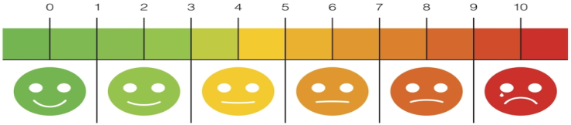  No difficulty/impact Severe difficulty/impact
Education setting | No difficulty/impact Severe difficulty/impact
Other  Please specify | No difficulty/impact Severe difficulty/impact

Request for Assistance – Part 3

ADDITIONAL INFORMATION
What has already been tried to help? How has that helped/not helped?
Medical Information
Diagnoses, medication, investigations pending, previous health, relevant family medical history, hearing/vision
Other Relevant Information
Social/Family Circumstances, Adoption or Fostering, Additional Support Needs, Child Protection Processes, Contact details of any additional carers if relevant
Other professionals Involved
OT, Physio, Dietitian, Paediatrician, Social Work, Educational Psychology, Pupil Support Service, Audiology, Other

Request for Assistance – Part 4

PARENT/CARER CONSENT
Parent/Carer consent is essential. Please confirm that consent has been obtained and the parent/carer is aware of the Request for Assistance content.
YES | NO
Name of parent/carer giving consent:

Signature and Designation of Person Making Request for Assistance:
Name:

Signature:

Designation/Role:

Date:

Contact Details:

PLEASE NOTE
- We have an open referral system. Anyone is welcome to make a request for assistance to the service
- Please complete all sections. Incomplete forms will be returned.
- You may be contacted for more information to help decision-making and planning a response to your request
- You will be copied into initial appointment letters and other relevant correspondence
- Please contact the Speech and Language Therapy Team if you require help completing the form
- You are welcome to complete the form on paper or electronically. Please contact the SLT Team if you require additional copies of the form (paper or electronic)

RETURNING THE REQUEST FOR ASSISTANCE & SPEECH AND LANGUAGE THERAPY CONTACT DETAILS
Email: ork.speechandlanguagetherapy@nhs.scot
Address: Speech and Language Therapy Department, The Balfour, Forelands Road, Kirkwall KW15 1NZ
Phone: 01856 888239 (direct)

We moved to the new Hospital and Healthcare Facility in June 2019

